**DISTRICT ATTORNEYS**

2025-27 Governor’s Requested Budget

Page intentionally left blank

# 

# TABLE OF CONTENTS

TABLE OF CONTENTS 3

CERTIFICATION 5

LEGISLATIVE ACTIONS 7

Agency Summary 8

2025-27 Governor’s Budget Chart 9

PROGRAM UNIT EXECUTIVE SUMMARY 10

PROGRAM UNIT NARRATIVE 17

Summary of 2025-27 Biennium Budget 19

Agencywide Program Unit Summary 25

Program Prioritization 26

Reductions 27

Essential Packages 28

Policy Packages 35

Special Reports 39

Information Technology Projects/Initiatives in 2025-27 40

Annual Performance Progress Report 41

AUDIT RESPONSE REPORT 47

2021-23 47

2019-21 47

2017-19 47

AFFIRMATIVE ACTION REPORT 48

Supervisory Ratio 49

ORBITS/ORPICS Reports 50

Page intentionally left blank

# Certification

I hereby certify that the accompanying summary and detailed statements are true and correct to the best of my knowledge

and belief and that the arithmetic accuracy of all numerical information has been verified.

19600 - District Attorneys and Their Deputies 417 2nd Street, Suite 101, Lake Oswego, Oregon 97034

Agency Name Agency Address

________________________________________ ___Authorized Representative for the District Attorneys_

Signature Title

Page intentionally left blank

**OREGON DISTRICT ATTORNEYS**

# LEGISLATIVE ACTIONS

Not Applicable

# Agency Summary

## Chart, pie chart AI-generated content may be incorrect.2025-27 Governor’s Budget Chart

**OREGON DISTRICT ATTORNEYS**

## PROGRAM UNIT EXECUTIVE SUMMARY

**PRIMARY OUTCOME AREA:** Safety

**SECONDARY OUTCOME AREA:** Healthy People

**PROGRAM CONTACTS:**

Bryan Brock ODAA Executive Director Phone: 541-527-0648

Vacant ODAA Coordinator Phone:

**PROGRAM UNIT NARRATIVE**

The agency is composed solely of 36 independently elected District Attorneys. The District Attorneys are directed by the Oregon Constitution and hundreds of state statutes to prosecute virtually all criminal conduct that occurs in Oregon. Additionally, the District Attorneys have multiple constitutional and statutory responsibilities beyond the prosecution of criminal cases. These responsibilities include, but are not limited to, ruling on public records requests, presenting evidence at mental fitness hearings, assisting in juvenile courts, advising local law enforcement, participation in the clemency and parole process, child support enforcement, and providing Constitutionally and statutorily mandated services to crime victims. District Attorneys manage offices that range in size from one elected District Attorney without any deputies to large offices with over 80 Deputy District Attorneys and hundreds of additional administrative and specialized support staff. Statewide there are over 430 Deputy District Attorneys.

**PROGRAM FUNDING REQUEST**

The District Attorney’s current service level of $19,596,588 in General Fund covers only the salaries and benefits of the 36 District Attorneys and centralized charges for the Department of Administrative Services and other statewide services.

**PROGRAM DESCRIPTION**

The mission of the Oregon District Attorney is to uphold the laws and Constitution of the State of Oregon and the United States Constitution, to preserve the safety of the public, to protect the rights of crime victims, and to pursue justice for all with skill, honor and integrity.

The Oregon Constitution, Article VII, Section 17, states District Attorneys *shall be the law officers of the State and of the counties within their respective districts*. As officers of the State Executive Branch, District Attorneys are charged with the duty to see that the laws are faithfully executed and enforced in order to maintain the rule of law. District Attorneys are state officers, elected locally by county and are non-partisan. Their term of office is four years.

The office of District Attorney is governed by ORS 8.610-8.852. The primary responsibility of the District Attorney is to prosecute state criminal offenses committed in their county by adults and juveniles.

In addition to the Oregon Criminal Code, more than 300 statutes either mandate or authorize additional responsibilities. These other legal duties include enforcing child support obligations in non-welfare cases, prosecuting civil forfeitures, ruling on public records requests, presenting evidence at mental fitness hearings, assisting in juvenile courts, and advising and representing county officers.

The duties of a District Attorney extend well beyond the prosecution of criminal laws. In conjunction with their public safety partners, they also seek to improve the safety of their communities and the administration of the criminal justice system. They serve as a key resource on public safety issues to legislators, local governments, and the public. District Attorneys throughout the state are active in Local Public Safety Coordinating Councils, Re-Entry Program Management Teams, Juvenile Crime Prevention Councils, County Management Teams, Drug & Alcohol Councils, other multi-disciplinary task forces, child abuse prevention teams, various Legislatively Adopted task forces and advisory committees, and community outreach and education activities. Additionally, some District Attorneys also serve as Medical Examiners.

**PROGRAM JUSTIFICATION & LINK TO LONG TERM OUTCOMES**

Former Governor Brown enumerated five long term outcomes:

* A Seamless System of Education
* A Thriving Statewide Economy
* Excellence in State Government
* Healthy, Safe Oregonians
* Responsible Environmental Stewardship

The performance of District Attorneys is linked directly to the long-term outcome: *Healthy, Safe Oregonians*. While the District Attorney’s performance is most obviously connected to Safety by criminal justice, it also supports the Healthy Oregonians outcome area, through child support enforcement, as well as helping to enhance local economies, safe communities, and the overall quality of life for the citizens of Oregon. The decisions of District Attorneys are based on the Oregon Constitution’s principles for the punishment of crime: "protection of society, personal responsibility, accountability for one's actions and reformation."

District Attorneys most often encounter individuals who have already committed a crime. The State's prosecutors are actively involved in prevention activities in their communities using Alternative and Specialty Courts. These courts provide services to offenders and avoid the use of prison space. The District Attorneys also enforce child support obligations, which help keep families economically stable.

**Strategy I**

District Attorneys believe that maintaining non-violent offenders in the community effectively ensures healthy and safe citizens and promotes excellence in state government. The District Attorneys were actively involved in the negotiations for justice reinvestment funds (HB 3194, 2013) to support community programs focused on reducing recidivism and eliminating or shortening prison and jail stays for eligible offenders. The District Attorneys are working closely with the Criminal Justice Commission and other community partners to assess the impact of this funding on the safety of Oregon’s communities.

Careful decisions made at the initial charging stage of a case and subsequent plea negotiating by prosecutors prior to trial help make the best use of state and county resources and keep the community safe from criminals. Since the 1980s, few if any sectors of state government, either in Oregon or nationally, have enjoyed the extraordinary success of Oregon’s public safety system. The district attorneys, working closely with other law enforcement professionals, the courts and community partners, are a critical component of the system’s unprecedented level of accomplishment.

**Strategy II**

District Attorneys promote a thriving statewide economy through the specialty and alternative courts they advocate for and participate in, especially drug courts. These courts create efficiencies by reducing costs, increasing treatment services, and preventing downstream costs by keeping families united. In addition to maintaining strict services and supervision for offenders, drug court programs help to find participants employment to keep their children out of the foster care system. These programs, operated through the leadership of District Attorneys, circuit court judges, defense attorneys and service providers and community partners, illustrate the success of our current public safety system.

Absent the use of specialty and alternative courts, many of the current participants are likely to be subject to felony convictions and, in some instances, sanctions that may include incarceration. In addition to the benefits cited above, participants in these alternative models can avoid or eliminate criminal histories that may have long term impacts on their ability to secure employment and services.

Additionally, in 2021, District Attorneys championed the passage of SB 218, which expanded the types of specialty courts which could offer a “conditional discharge” to successful participants. Making a successful treatment court participant eligible for “conditional discharge” means that their case can be dismissed without having a criminal conviction on the successful participant’s record.

**Strategy III**

There are many ways District Attorneys ensure the safety of people in our communities. Through their advocacy for effective public safety policies and their sound charging practices, District Attorneys helped the State to achieve an over 50% decrease in the rate of violent crimes. Since 1995, only one other state enjoyed a steeper reduction. The Oregon Progress Board named Public Safety as one of only two sectors meeting state benchmarks in 2009. Part of that success is attributable to mandatory minimum sentencing laws such as Measure 11, which was approved by Oregonians twice by significantly wide margins. These laws provide greater uniformity of sanctions statewide.

District attorneys are active advocates for the adoption of effective changes in public safety statutes. Over the past 15 years, they actively supported laws to regulate pseudoephedrine, which led to steep reductions in methamphetamine labs and addiction; laws to address the epidemic of repeat property crimes to get these offenders to prison for sentence sufficient to allow them to receive services for the addictions that frequently are a factor leading to their criminal behavior; and laws authorizing reductions in sentences for some non-violent offenders with a focus on reinvesting the savings in programs that reduce recidivism and improve the safety of our communities.

**Strategy IV**

Prosecutors strive for excellence in state government in their daily work through collaboration with community partners, by holding offenders accountable, protecting crime victims' rights, and seeking a balanced approach to criminal justice. District Attorneys advocate strongly for the entire public safety infrastructure. Advocacy efforts include keeping courts open and accessible, stable and permanent funding for the Oregon State Police services and personnel, for salaries commensurate with the work done by public defenders and their own deputies, by enforcing laws for justice, and by identifying issues unique to their counties and crafting community-based solutions to resolve them.

**PROGRAM PERFORMANCE**

The performance of Oregon’s District Attorneys, like all elected officials, is measured on the ballot. Every four years each District Attorney is evaluated by county voters and, overwhelmingly, the state’s 36 district attorneys are re-elected if they choose to continue in the position. And often they do. Unlike other states, Oregon’s District Attorneys are almost universally lifelong prosecutors rather than politicians with an eye towards higher office. They understand the challenges of achieving justice, making difficult decisions as to charging a case based on the evidence, enforcing the laws of the State fairly and without prejudice, careful managing complex budgets to meet the needs of their constituents most effectively, and ensuring the rights of victims are enforced. Based on these factors and many more, the District Attorneys’ performance is measured by voters. Nevertheless, the District Attorneys and their Deputies identified the following performance measures, recognizing that the costs of achieving these measures are not funded through the District Attorneys budget. Rather, they are funded through county general fund or other state and/or federal resources. A District Attorneys 2021 budget note report established that counties provided approximately 75% of the funding for prosecutors in Oregon.

**- Early Resolution & Specialty Courts**

Virtually every county has some sort of early resolution or specialty court. Over the last decade over two dozen new courts have been established, including but not limited to Veteran's courts, HOPE courts, Juvenile courts, and Domestic Violence courts. These courts substantially reduce the number of offenders receiving jail or prison sentences and offer a wide range of court sanctioned treatment programs to help reduce the number of future victimizations and decrease crime in our communities.

**- Child Support Enforcement**

District Attorneys in some counties enforce and collect child support in cases where the participants never received public assistance. These collections are integral to providing an important economic safety net for Oregon's families. District Attorneys work in partnership with the Department of Justice’s Division of Child Support to collect child support. 17 of 36 District Attorney offices provide child support services. From October 1, 2023, through September 30, 2024, District Attorneys collected $98,915,547 in child support. This represents 30.5% of the total child support program collections in the Oregon program. The table below provides collection rates for District Attorney offices compared to the total program collections. The total program collections include the Department of Justice public and non-public assistance cases and the District Attorney non-public assistance cases.

|  |  |
| --- | --- |
| **Program Collections** | **FFY 2024** |
| DA Collections | $98,915,547 |
| DCS Collections | $225,345,541 |
| **Total Program Collections** | **$324,261,088** |

**- Discretion & Case Resolution**

Through Early Disposition Programs and plea negotiations, District Attorneys create system-wide savings. The significant number of cases are settled through plea negotiations, in which defendants represented by defense attorneys plead guilty to charges lesser than those for which they could have been convicted, saving court and corrections resources. Additionally, many counties employ specialty courts to facilitate early case resolution.

**- Enabling Legislation/Program Authorization**

Article VII, Section 17 of the original Oregon Constitution states, *There shall be elected by districts comprised of one, or more counties, a sufficient number of prosecuting Attorneys, who shall be the law officers of the State, and of the counties within their respective districts, and shall perform such duties pertaining to the administration of Law, and general police as the Legislative Assembly may direct.* The office of the District Attorney is governed by ORS 8.610-8.852.

**FUNDING STREAMS**

The salaries of the 36 elected District Attorneys and the state-mandated assessments are funded with General Fund dollars. State funding of District Attorney salaries was intended to eliminate potential conflicts with county officials (functioning in the same manner as judges' salaries), and to introduce a level of professionalism through stable salaries that would attract and retain highly qualified attorneys for the State. State compensation of elected District Attorneys, like that of state court judges, has not kept up with attorney compensation in the public or private sector. In 1971, the State and the counties agreed to share responsibility for the costs of prosecution. Except for a few grants funded positions, the over 430 Deputy District Attorneys representing the State are currently compensated entirely by the counties. The State eliminated funding for the deputies in 2005, brought back funding in the biennium 2007-2009 in the amount of $444,392 and eliminated it again in the biennium 2009-2011. Since 2011, the District Attorneys and their Deputies have received no funding beyond the payment of District Attorney salaries, benefits and other state mandated fees.

## PROGRAM UNIT NARRATIVE

**Background**

The District Attorneys are a state agency, however there are no administrative employees listed in its budget, past or present. Currently, the non-profit Oregon District Attorneys Association, Inc. (ODAA) serves as a centralized resource for District Attorneys and their staff by providing statewide continuing education training, interoffice and governmental communications, budget and program development, and as a resource to the Legislature and the Governor’s office.

The ODAA, currently contracts with a full-time executive director to manage the association work. Additionally, the Attorney General’s office provides funding for a full-time coordinator position. Together these two positions work to deliver the wide range of required services and to provide consistency for the 36 elected District Attorneys, its approximately 500 members, and public safety partners.

**Unmet Service Priorities**

**- No centralized staffing**

Oregon’s District Attorneys do not have dedicated state administrative support for the agency, except for the crucial ancillary support provided by the Department of Justice. As a result, coordination of services across the state is diminished, and moreover, typical agency function, such as budget production, record-keeping and response to statewide requirements such as performance measures are undertaken by non-district attorney employees.

**- Implementation of SB 505 (Grand Jury Recording)**

In 2017, SB 505 was passed and required that all grand jury proceedings be audio recorded. Compliance and implementation of SB 505 required District Attorney offices to be trained on the recording equipment and plans needed to be developed for the long-term secured storage of the audio files and for the cost of transcription of the audio files if requested. District Attorneys working with the Department of Justice have reached contracts with vendors to provide transcription services. Additionally, the Oregon Department of Justice Information Services Section, working with District Attorneys, developed and implemented a DOJ managed solution, security, backup, maintenance and customer support for the grand jury audio files, and this system is operational. Finally, the Oregon Judicial Department has provided training on the grand jury recording equipment for District Attorneys.

## Graphical user interface, application, table, Excel AI-generated content may be incorrect.Summary of 2025-27 Biennium Budget

## Agencywide Program Unit Summary

## Table AI-generated content may be incorrect.Program Prioritization

## Reductions

## Essential Packages

**District Attorneys**

#### 010 – Non-PICS Personal Svc / Vacancy Factor

**Purpose:** This package includes the following adjustments: adjustment for mass transit taxes and PERS bond assessment (PBA).

**How Achieved:** Accounts were adjusted using the DAS published instructions.

2025-27/2027-29 Staffing Impact: None

Revenue Source: $(42,157) General Fund

#### 022 – Phase-out Pgm & One-time Costs

**Purpose:** This package backs out one-time General Fund funding for grand jury recordation

**How Achieved:** Accounts were adjusted to backout one-time GF funding

2025-27/2027-29 Staffing Impact: None

Revenue Source: ($1,550,000) General Fund

#### 031 – Standard Inflation and State Government Service Charge

Purpose: Standard inflation of 4.2% was applied to all services and supply accounts except for rent and state government services charges. The package also adjusts the state government service charges assessed by DAS, Secretary of State Audits Division, State Library, Supreme Court Library, Risk Management, and others. Inflation of 4.2% was applied to non-uniform rent and the Attorney General budget was inflated by 17.70%.

How Achieved: Accounts were adjusted using the DAS published instructions.

2025-27/2027-29 Staffing Impact: None

**Revenue Source:** $1,506,566 General Fund

#### District Attorneys

**031 and 032 Continued – SGSC Assessments**

## Policy Packages

**093 – Statewide Adjustment DAS Chgs**

**Purpose:** This package represents adjustments to State Government and DAS pricelist charges for services made in the Governor’s Budget

**How Achieved:** Accounts were adjusted using the DAS published instructions.

**2025-27/2027-29 Staffing Impact:** None

Revenue Source: $65,134 General Funds

#### 

Page intentionally left blank

**Detail of Lottery Funds, Other Funds, and Federal Funds Revenue**

Not Applicable

**District Attorneys and Their Deputies**

# Special Reports

## Information Technology Projects/Initiatives in 2025-27

Not Applicable

## Text, letter AI-generated content may be incorrect.Annual Performance Progress Report

## AUDIT RESPONSE REPORT

## 2021-23

No audits to report.

## 2019-21

No audits to report

## 2017-19

No audits to report.

## AFFIRMATIVE ACTION REPORT

## Supervisory Ratio

Not Applicable

## ORBITS/ORPICS Reports

**ORBITS Reports**

* BSU003A – Summary Cross Reference Listing and Packages
* BSU004A – Policy Package List by Priority
* BDV103A – Budget Support – Detail Revenues and Expenditures (Agencywide/SCR Levels)
* ANA100A – Version/Column Comparison – Detail (Base budget by SCR)
* ANA101A – Package Comparison – Detail (Essential and Policy Packages by SCR)

**ORPICS Reports**

* PICS100 – Position Budget Report list by DCR

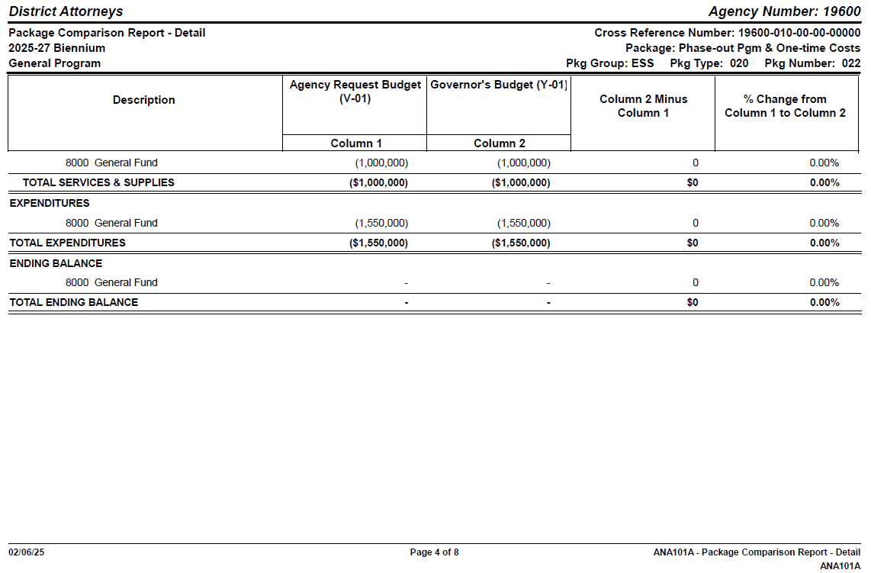

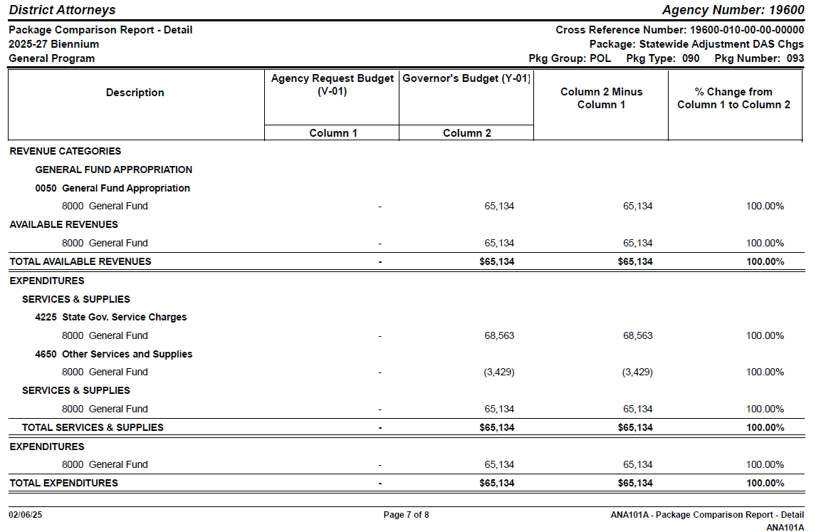

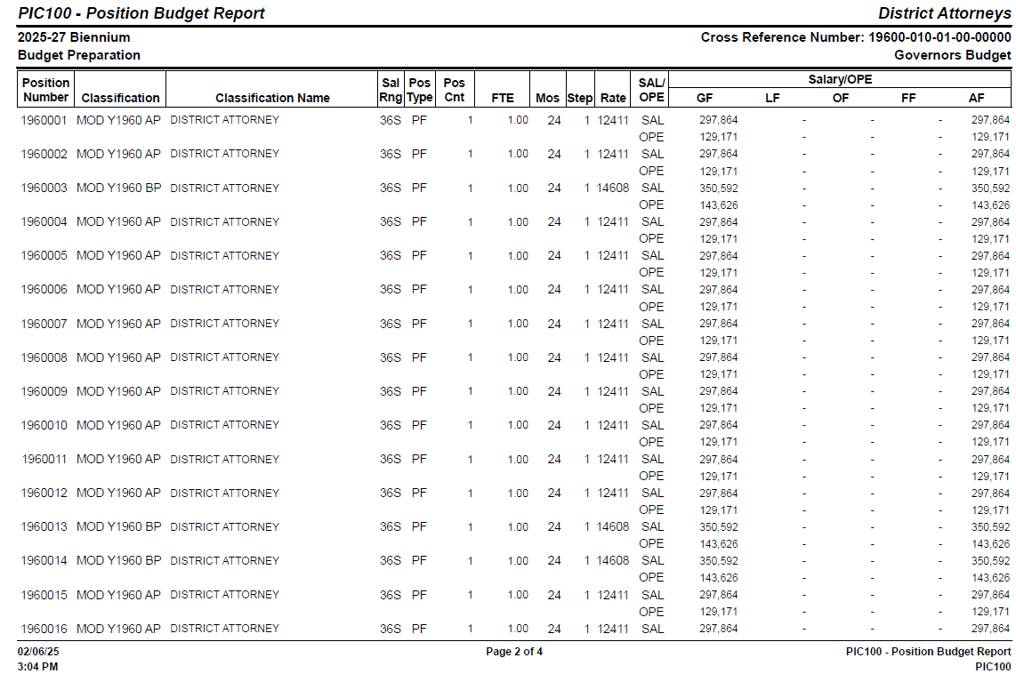

Page intentionally left blank